Names, class: ______________________________________________________

Digestive System Model
Follow these steps:
- Place the banana and cookies inside the SMALL ziplock bag = “eat”. Slowly add A LITTLE BIT of water = “saliva”. LET ALL THE AIR OUT and zip the bag shut. Then smash all the ingredients with your hands until no more clumps are present = “chew” your mix.
- Now the mix (“bolus”) needs to go from the mouth (the small bag) via the esophagus to the “stomach” (the big bag). Squeeze the food into one end of the small bag. Tilt the bag up slightly and cut a small hole in the opposite corner of the bag. Squeeze the bolus through the hole (the “esophagus”) into the large bag (the “stomach”).
- Add some gastric juice to the mix in the stomach: lemon juice (“hydrochloric acid”), powder (“pepsin”), and butter (“mucus”). Continue mashing it.
- From the stomach, the food (“chyme”) needs to pass into the tights (the “small intestine”). Squeeze the contents of the bag into the cut-off tights while holding everything above the trey.
- Add a drop of “bile” (balsamic reduction) into the starting section of the small intestines = “duodenum”.
- Squeeze the food through the tights. Keep squeezing to let the liquid run out. (Note that in real life much of the water is actually absorbed in the large intestines, not the small!)
- Eventually, cut the toe off the tights and squeeze the waste food out into the paper cup (“large intestine”). Make sure to have cut off a SMALL (1 cm radius) hole on the bottom of the cup (“anus”).
- Finally, push the waste food through the bottom of the cup onto the tray to model defecation (pooping).

Label and complete:
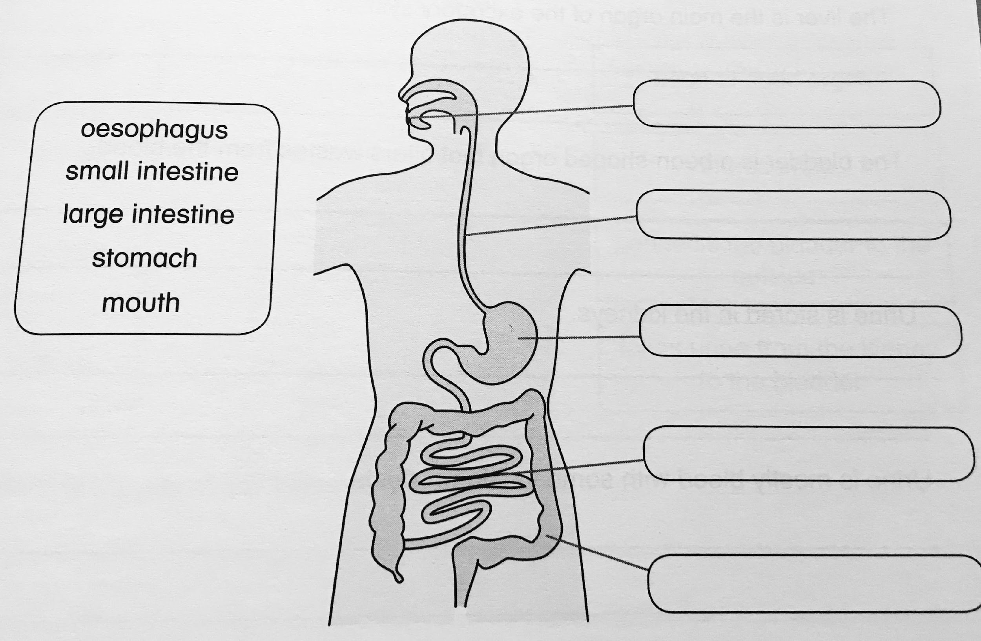
Organ or structure | Equivalent in the model? | Function & notes
Mouth

Esophagus

Stomach

Gastric juice (3 components)

Small intestines

Bile

Nutrients

Large intestine

Anus

